Task Submitted by:
Rubab Fatima
Student record system

1. Introduction
This project is a complete Full Stack CRUD (Create, Read, Update, Delete) web application developed for managing student records. The application provides a modern frontend interface, a backend REST API, and a SQLite database for data storage.
The project demonstrates the implementation of complete CRUD functionality using modern web development technologies. The application allows users to add, view, update, search, filter, and delete student records efficiently.
The main purpose of this project is to understand how frontend and backend systems communicate with each other and how databases are used to store and manage data in real-world applications.

2. Project Objectives
The main objectives of this project are:
- To develop a complete full-stack CRUD application.
- To implement frontend and backend integration.
- To perform all CRUD operations successfully.
- To understand REST API development.
- To implement database connectivity and persistence.
- To create a responsive and user-friendly interface.
- To maintain clean and structured project architecture.
- To validate user input and handle errors properly.

3. Project Overview
The developed application is a Student Record Management System where users can:
- Add new students.
- View all student records.
- Search students by name or email.
- Filter students by department.
- Edit student information.
- Delete student records.
- View student statistics.
The project follows a client-server architecture where:
- The frontend handles the user interface.
- The backend processes requests and business logic.
- SQLite stores all student data.

4. Technologies Used

Frontend Technologies
- HTML5
- CSS3
- Vanilla JavaScript

Backend Technologies
- Node.js
- Express.js

Database
- SQLite
- better-sqlite3

Additional Tools
- REST API
- Fetch API
- CORS
- JSON

5. System Architecture
The application follows a three-layer architecture:

1. Frontend Layer
The frontend provides the user interface and handles user interactions.
Responsibilities:
- Display data
- Send requests to backend
- Receive API responses
- Update UI dynamically

2. Backend Layer
The backend acts as the bridge between frontend and database.
Responsibilities:
- Handle API requests
- Validate user input
- Process business logic
- Perform database operations
- Return responses

3. Database Layer
The database stores student information permanently.
Responsibilities:
- Store records
- Retrieve records
- Update records
- Delete records

6. Frontend Design
The frontend was developed using HTML, CSS, and JavaScript.

Frontend Features

Responsive Design
The interface is fully responsive and works on:
- Desktop
- Tablet
- Mobile devices

Student Table
Displays all student records in a structured table format.

Search Functionality
Users can search students by:
- Name
- Email

Department Filtering
Users can filter students according to departments.

Modal Forms
Popup modal forms are used for:
- Adding students
- Editing students

Toast Notifications
Toast messages provide feedback for:
- Successful operations
- Error handling

Statistics Dashboard
Dashboard cards display:
- Total students
- Department counts
- Application statistics

7. Backend Development
The backend was developed using Node.js and Express.js.

Backend Features

REST API
A complete REST API was implemented with CRUD endpoints.

Validation Middleware
Server-side validation ensures:
- Required fields are filled
- Proper email format
- Data integrity

Error Handling
Proper error handling was implemented using:
- HTTP status codes
- JSON error messages

CORS Support
CORS was enabled to allow communication between frontend and backend.

Security Features
The application prevents:
- Invalid requests
- SQL injection
- Incorrect data submission

8. Database Design
SQLite database was used for storing student records.

Database Table: Students
Column Name | Data Type | Description
id | INTEGER | Primary key
name | TEXT | Student name
email | TEXT | Student email
age | INTEGER | Student age
department | TEXT | Department name
semester | INTEGER | Current semester
created_at | TEXT | Record creation timestamp
updated_at | TEXT | Last update timestamp

Database Features
- Auto-increment IDs
- Unique email constraint
- Persistent storage
- Timestamp tracking

9. CRUD Operations Implementation

1. CREATE Operation
The Create operation allows users to add new student records.

Process
- User fills the form.
- Frontend sends POST request.
- Backend validates data.
- Database stores the record.
- UI updates automatically.

Endpoint
POST /api/students

2. READ Operation
The Read operation retrieves all student records.

Process
- Frontend sends GET request.
- Backend fetches records.
- Database returns data.
- UI displays student table.

Endpoint
GET /api/students

3. UPDATE Operation
The Update operation modifies existing student data.

Process
- User clicks edit button.
- Modal form opens.
- User updates information.
- Frontend sends PUT request.
- Database updates record.
- UI refreshes automatically.

Endpoint
PUT /api/students/:id

4. DELETE Operation
The Delete operation removes student records.

Process
- User clicks delete button.
- Confirmation dialog appears.
- Frontend sends DELETE request.
- Database removes record.
- UI updates automatically.

Endpoint
DELETE /api/students/:id

10. Data Flow Between Frontend and Backend
The application follows a structured data flow process.

Data Flow Steps
- User interacts with frontend.
- JavaScript sends API request using Fetch API.
- Backend receives request.
- Backend processes logic.
- Database operation executes.
- Backend returns JSON response.
- Frontend updates UI dynamically.
This ensures smooth communication between frontend and backend systems.

11. User Interface Features
The application contains several UI enhancements for better user experience.

Key UI Features

Modern Design
- Clean layout
- Professional appearance
- Easy navigation

Responsive Layout
Works across multiple screen sizes.

Dynamic Updates
UI updates instantly after each CRUD operation.

Search and Filtering
Users can easily find specific records.

Interactive Forms
Modal forms simplify data entry.

Notifications
Toast notifications improve usability.

12. Validation and Error Handling
Validation and error handling were implemented on both frontend and backend.

Frontend Validation
- Empty field checking
- Email format validation
- Required field validation

Backend Validation
- Request validation
- Data sanitization
- Duplicate email prevention

Error Handling
The application handles:
- Invalid requests
- Missing fields
- Database errors
- Server errors

13. API Endpoints
Method | Endpoint | Description
GET | /api/students | Fetch all students
GET | /api/students/:id | Fetch single student
POST | /api/students | Create new student
PUT | /api/students/:id | Update student
DELETE | /api/students/:id | Delete student

14. Project Folder Structure
project-root/
│
├── backend/
│ ├── server.js
│ ├── routes/
│ ├── database/
│ ├── middleware/
│ └── models/
│
├── frontend/
│ ├── index.html
│ ├── style.css
│ ├── script.js
│ └── assets/
│
├── database/
│ └── students.db
│
├── README.md
├── QUICK_START.md
├── SETUP_INSTRUCTIONS.md
└── package.json

15. Application Features

CRUD Features

Create
- Add new students
- Form validation
- Instant UI updates

Read
- Display all records
- Dynamic data loading
- Search functionality

Update
- Edit student information
- Modal editing forms
- Real-time refresh

Delete
- Remove records
- Confirmation popup
- Automatic UI updates

Additional Features
- Responsive design
- Statistics dashboard
- Search and filter system
- Toast notifications
- Clean architecture
- Error handling

16. Screenshots / Demo Section

Suggested Screenshots

Home Dashboard

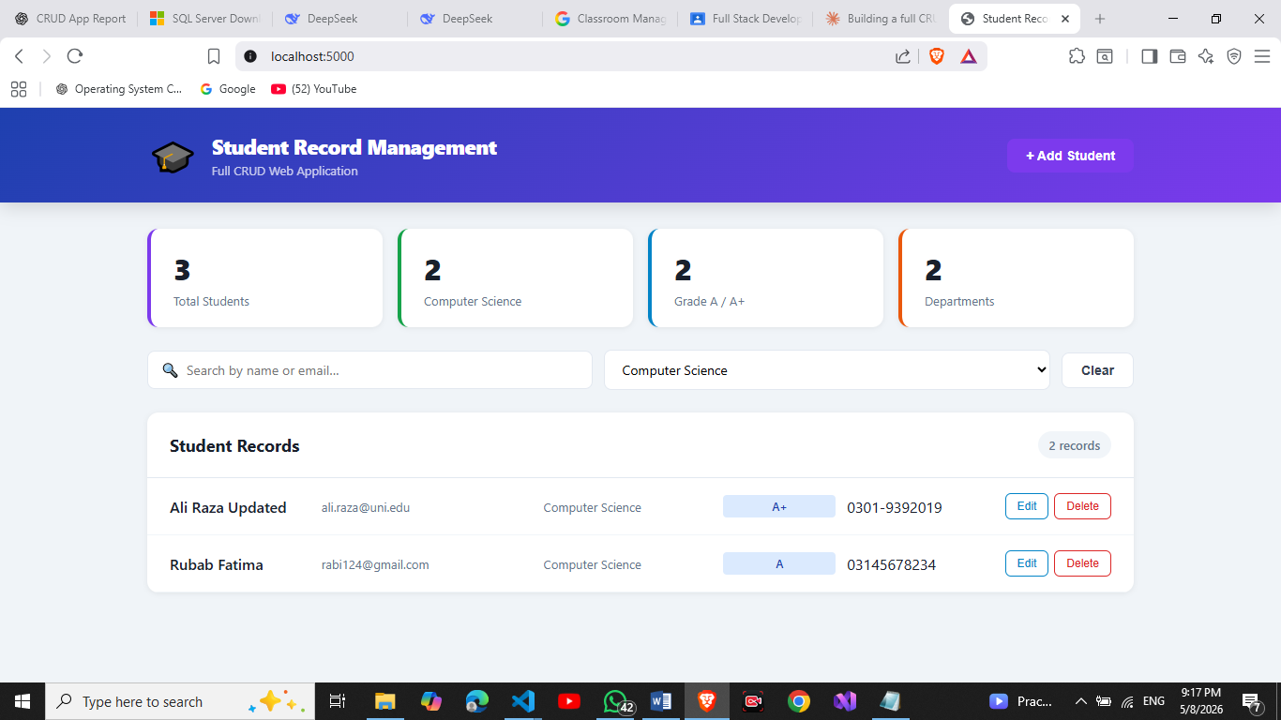

Add Student Form

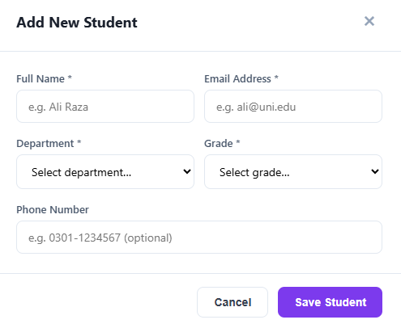

Student Records Table

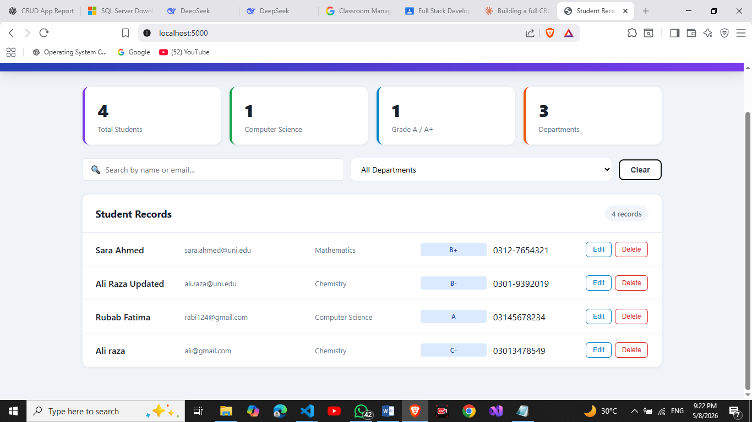

Edit Student Model
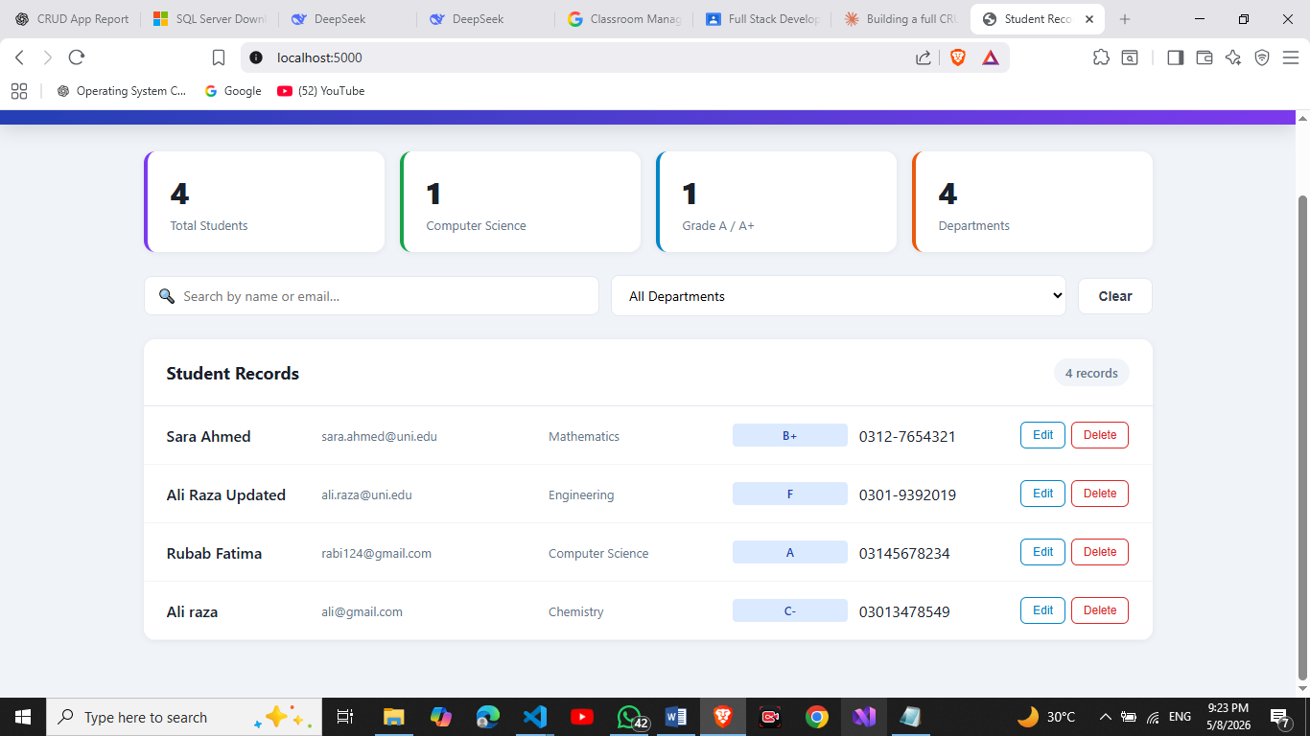
Record of Ali Raza Updated is updated successfully.

Delete Confirmation

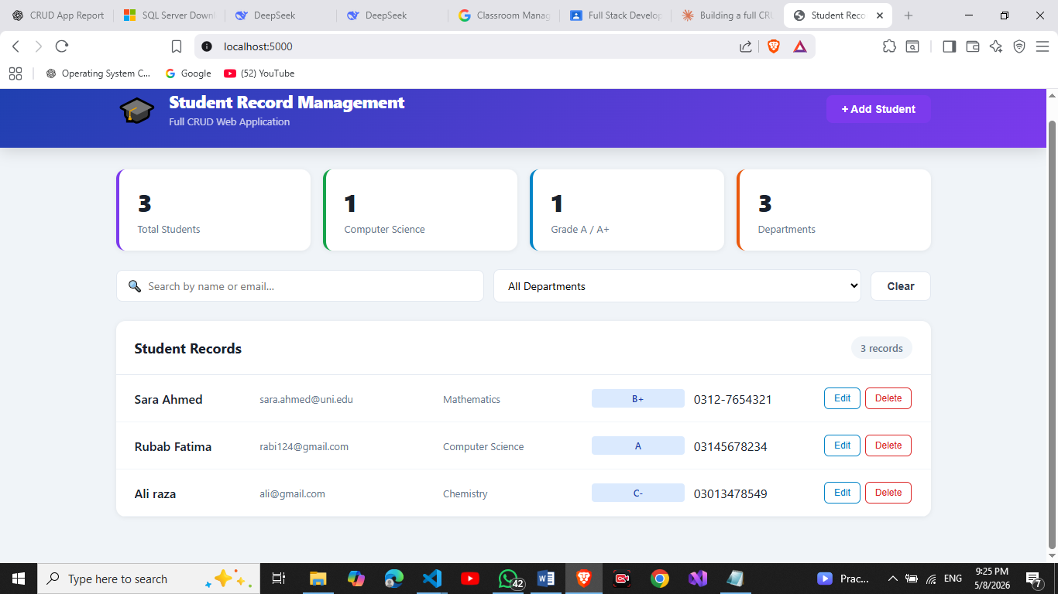

Record of Ali Raza updated is deleted sucessfully

Search and Filter

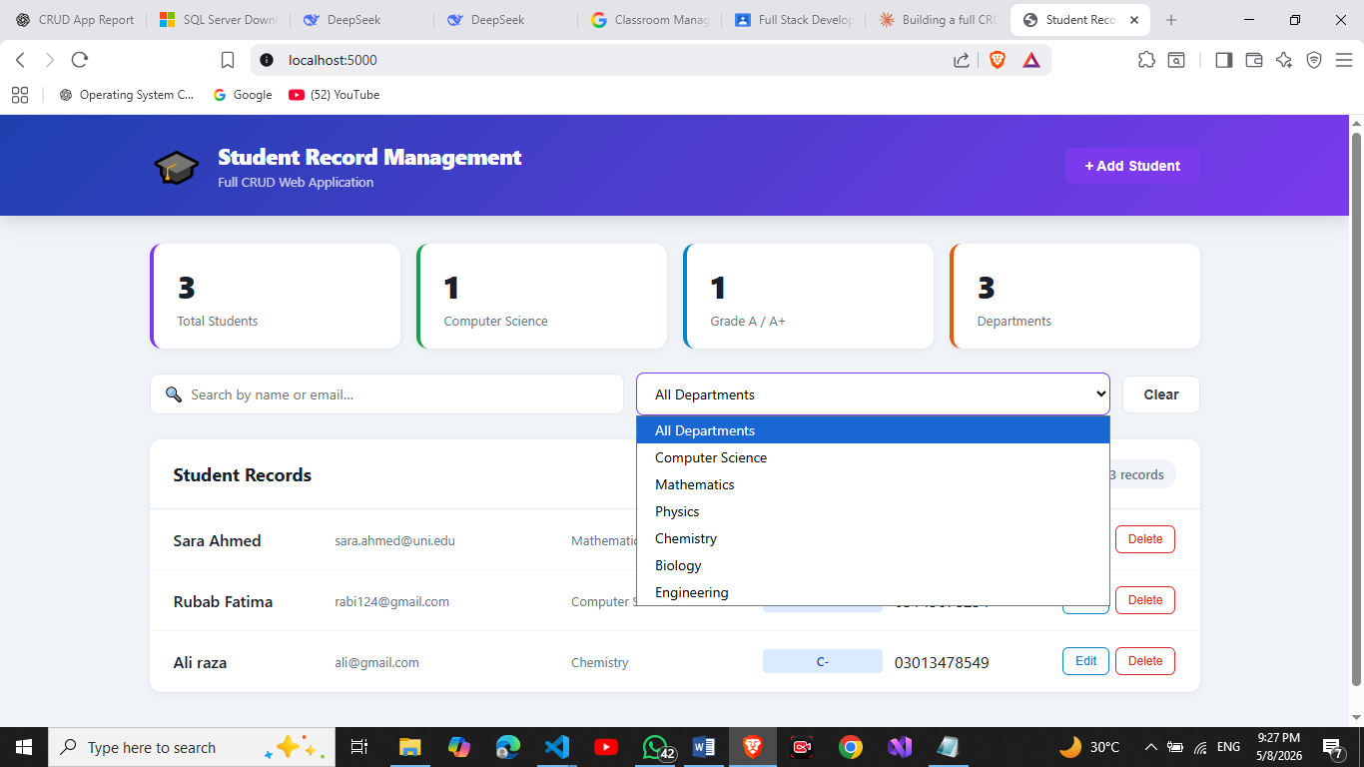.

17. Challenges Faced
During development, several challenges were encountered:

1. Frontend and Backend Integration
Understanding API communication between frontend and backend required careful implementation.

2. Database Connectivity
Configuring SQLite and handling queries correctly required testing.

3. Dynamic UI Updates
Ensuring the UI refreshed immediately after CRUD operations required proper state handling.

4. Validation
Both frontend and backend validation needed to work together for better security.

5. Responsive Design
Designing layouts for multiple screen sizes required additional CSS adjustments.

18. Learning Outcomes
This project helped in learning:
- Full stack web development
- REST API development
- Database integration
- CRUD operations
- Frontend and backend communication
- Responsive UI design
- Validation and error handling
- Project architecture and organization
- Real-world application development

19. Conclusion
The Complete CRUD Application project was successfully developed and implemented. The application fulfills all required functionalities including Create, Read, Update, and Delete operations.
The project demonstrates a proper full-stack architecture

